Cherluk Sumdin
ITAI1378
September 3, 2026
Dominion of OpenCV and Pillow – A Day in Life
8 AM – Start the day
I arrived at work at 8:00 AM and started my day by checking the images that I needed to process. My team gave me a folder containing many images for our company website. Some of the images were different sizes and formats, so they needed to be processed before they could be uploaded. I decided to use Python with Pillow and OpenCV to complete my work.
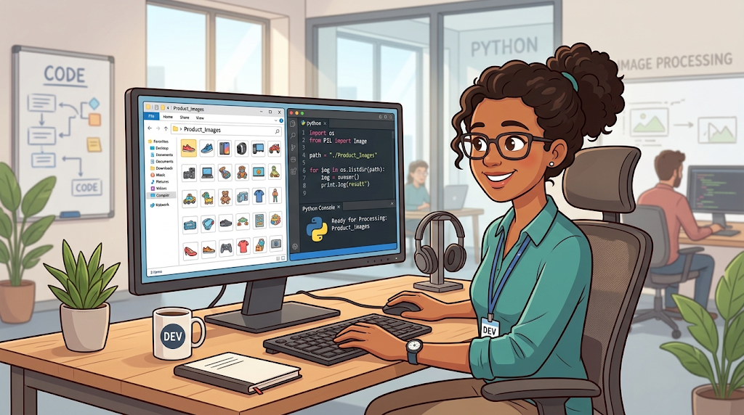

9 AM – Working with Pillow
I started working on the product images using Pillow. Some of the images were too large or had different dimensions. I used Pillow to resize the images so they would have a similar size for the company website. I also used the crop feature to remove unnecessary areas around some of the products. Pillow made these basic image editing tasks simple to do with Python.
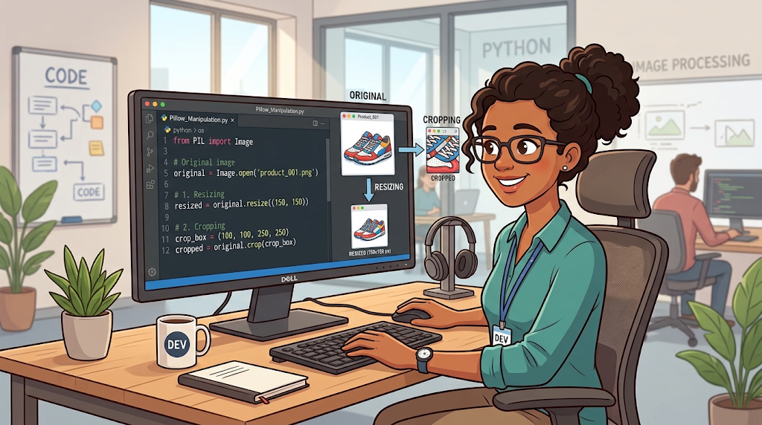
11 AM - Working with Pillow
I noticed that some of the product images were saved in different file formats. Some images were PNG files, but I needed JPEG files for the website. I used Pillow to open the PNG images and convert them into JPEG format. This helped me keep the product images in the correct format and ready to be uploaded to the website.
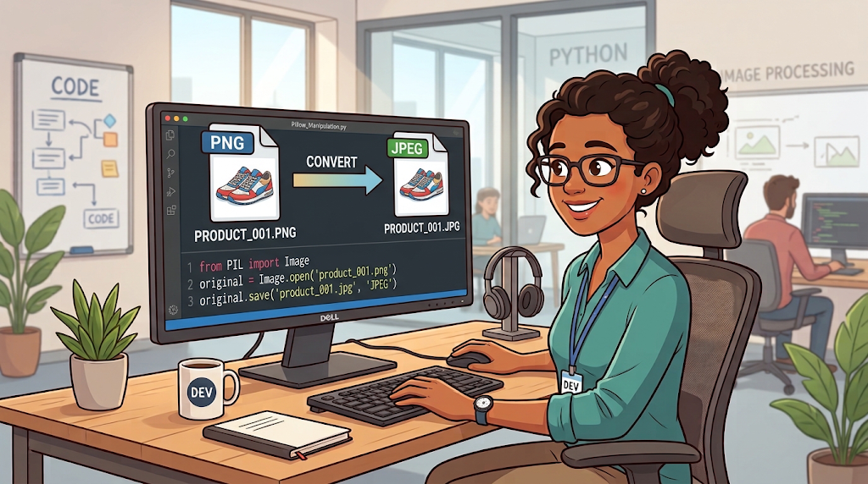
1 PM - Working with OpenCV
I started using OpenCV to process the product images. I converted some of the color images into grayscale so I could work with simpler image data. Grayscale images use shades of gray instead of full color, which can make some image processing tasks easier. OpenCV made it simple to convert the images and prepare them for more advanced processing.
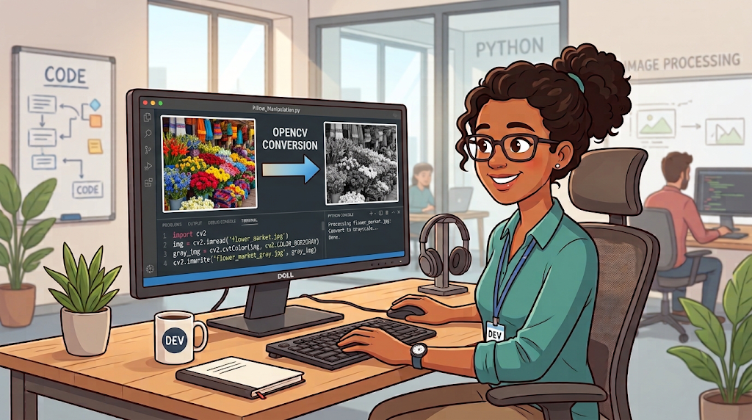
2 PM - Working with OpenCV
I continued using OpenCV to improve and analyze the product images. I used blurriness to reduce noise and make an image look smoother. I also used sharpening to make important details and edges clearer. Finally, I tried edge detection to identify the outlines and shapes of objects in the image. These tools helped me see how OpenCV can be used for more advanced image processing.
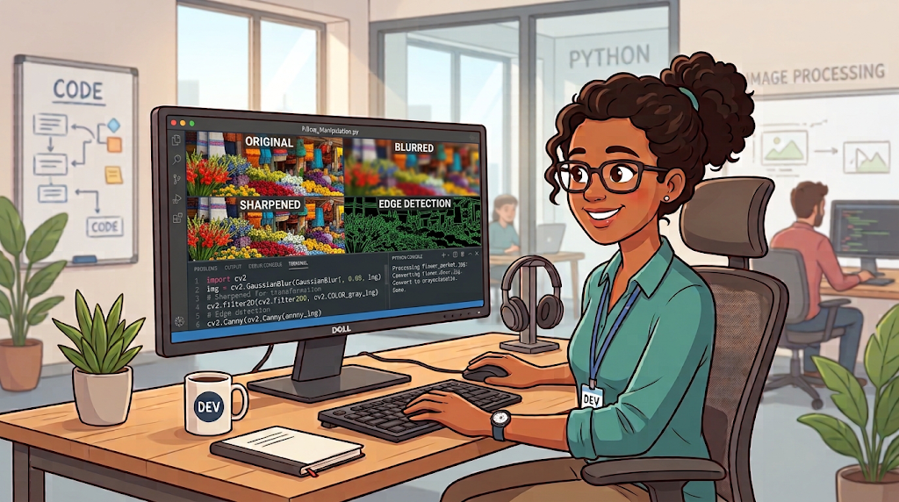
4 PM - Working with Pillow and OpenCV
I finished processing the product images and checked the results. I used OpenCV for image processing and Pillow for basic image editing and saving the images in the correct format. I organized the finished images into a folder, so they were ready to be uploaded to the company website. Using both OpenCV and Pillow helped me completed different image processing tasks throughout the day.

Journal
Before this assignment, I knew that we could use Python to work with image processing, but I have never done it before. I did not know about these two libraries, OpenCV and Pillow. I learned that Pillow is useful for basic image editing tasks such as resizing, cropping, and converting. OpenCV provides more advanced image processing tools such as converting images to grayscale, smoothing, sharpening, and edge detection.
For this challenge, I approached the assignment by creating a day in life of a developer who works with product images for a company website. I created a timeline that showed different tasks throughout the developer's workday. In the morning, the developer used Pillow to resize and crop product images and convert them into different image formats. Later in the day, the developer used OpenCV to convert images to grayscale and apply different image processing techniques. I also used visual examples to show how each technique changed the original image.
I believe these libraries can be useful for many computer vision projects because they provide different tools for preparing, editing, and analyzing images. Pillow can handle many simple image editing tasks, while OpenCV can be useful when more advanced image processing is needed. This assignment helped me understand the use of OpenCV and Pillow and how to use them in a real world scenario.

